Camera | Battery | External Battery | Storage | Usage
Hero Black 13  ($320) | 108 min 4K/30fps  90 min 4K/60fps  163 min 1080/30fps | Yes, replace Enduro GoPro battery ($76.49)  Allow Magnet cable charger ($99.99) | support up to 1 TB microSD cards, from different companies  1TB: ~40 hr (4K/30 fps), ~20 hr (4K/60 fps) | high-res, high-frame-rate shooting or long sessions
Hero Black 12  ($300) | 102 min 4K/30fps,  80 min 4K/60fps,  150 min 1080/30fps | Yes, replace Enduro GoPro battery ($59.49)
MAX 2  ($400) | 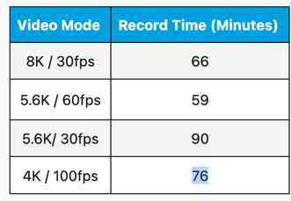 | Yes, replace with MAX goPro battery ($67.99) |  | immersive 360° video, VR, 360/8K
HERO  ($200) | ~92 min 4K/30fps  ~141 min 1080/30fps | No, no removable battery, must use USB-C |  | good for portability and simplicity
LIT HERO  ($230) | ~113 min 4K/30fps  ~175 min 1080/30fps | No, no removable battery, must use USB-C
Battery
https://community.gopro.com/s/article/gopro-camera-battery-life?language=en_US
Hero13 black battery (2) and charger ($76.49):
https://gopro.com/en/rs/shop/mounts-accessories/hero13-black-dual-battery-charger-enduro-batteries/AEDBD-201-master.html
Hero 12 black battery (2) and charter ($59.49):
https://gopro.com/en/rs/shop/mounts-accessories/hero10-black-dual-battery-charger-enduro-batteries/ADDBD-211-master.html
MAX2 battery (2) and charger ($67.99)
https://gopro.com/en/rs/shop/mounts-accessories/max2-dual-battery-charger-enduro-batteries/AMDBD-001-master.html
HERO, LIT HERO (built in battery)

SD card
https://community.gopro.com/s/article/microSD-Card-Considerations?language=en_US
Samsung 1TB sd card (~$100):
https://www.amazon.com/SAMSUNG-microSD-MicroSDXC-MB-MD1T0SA-AM/dp/B0CWPNS8JY?th=1

